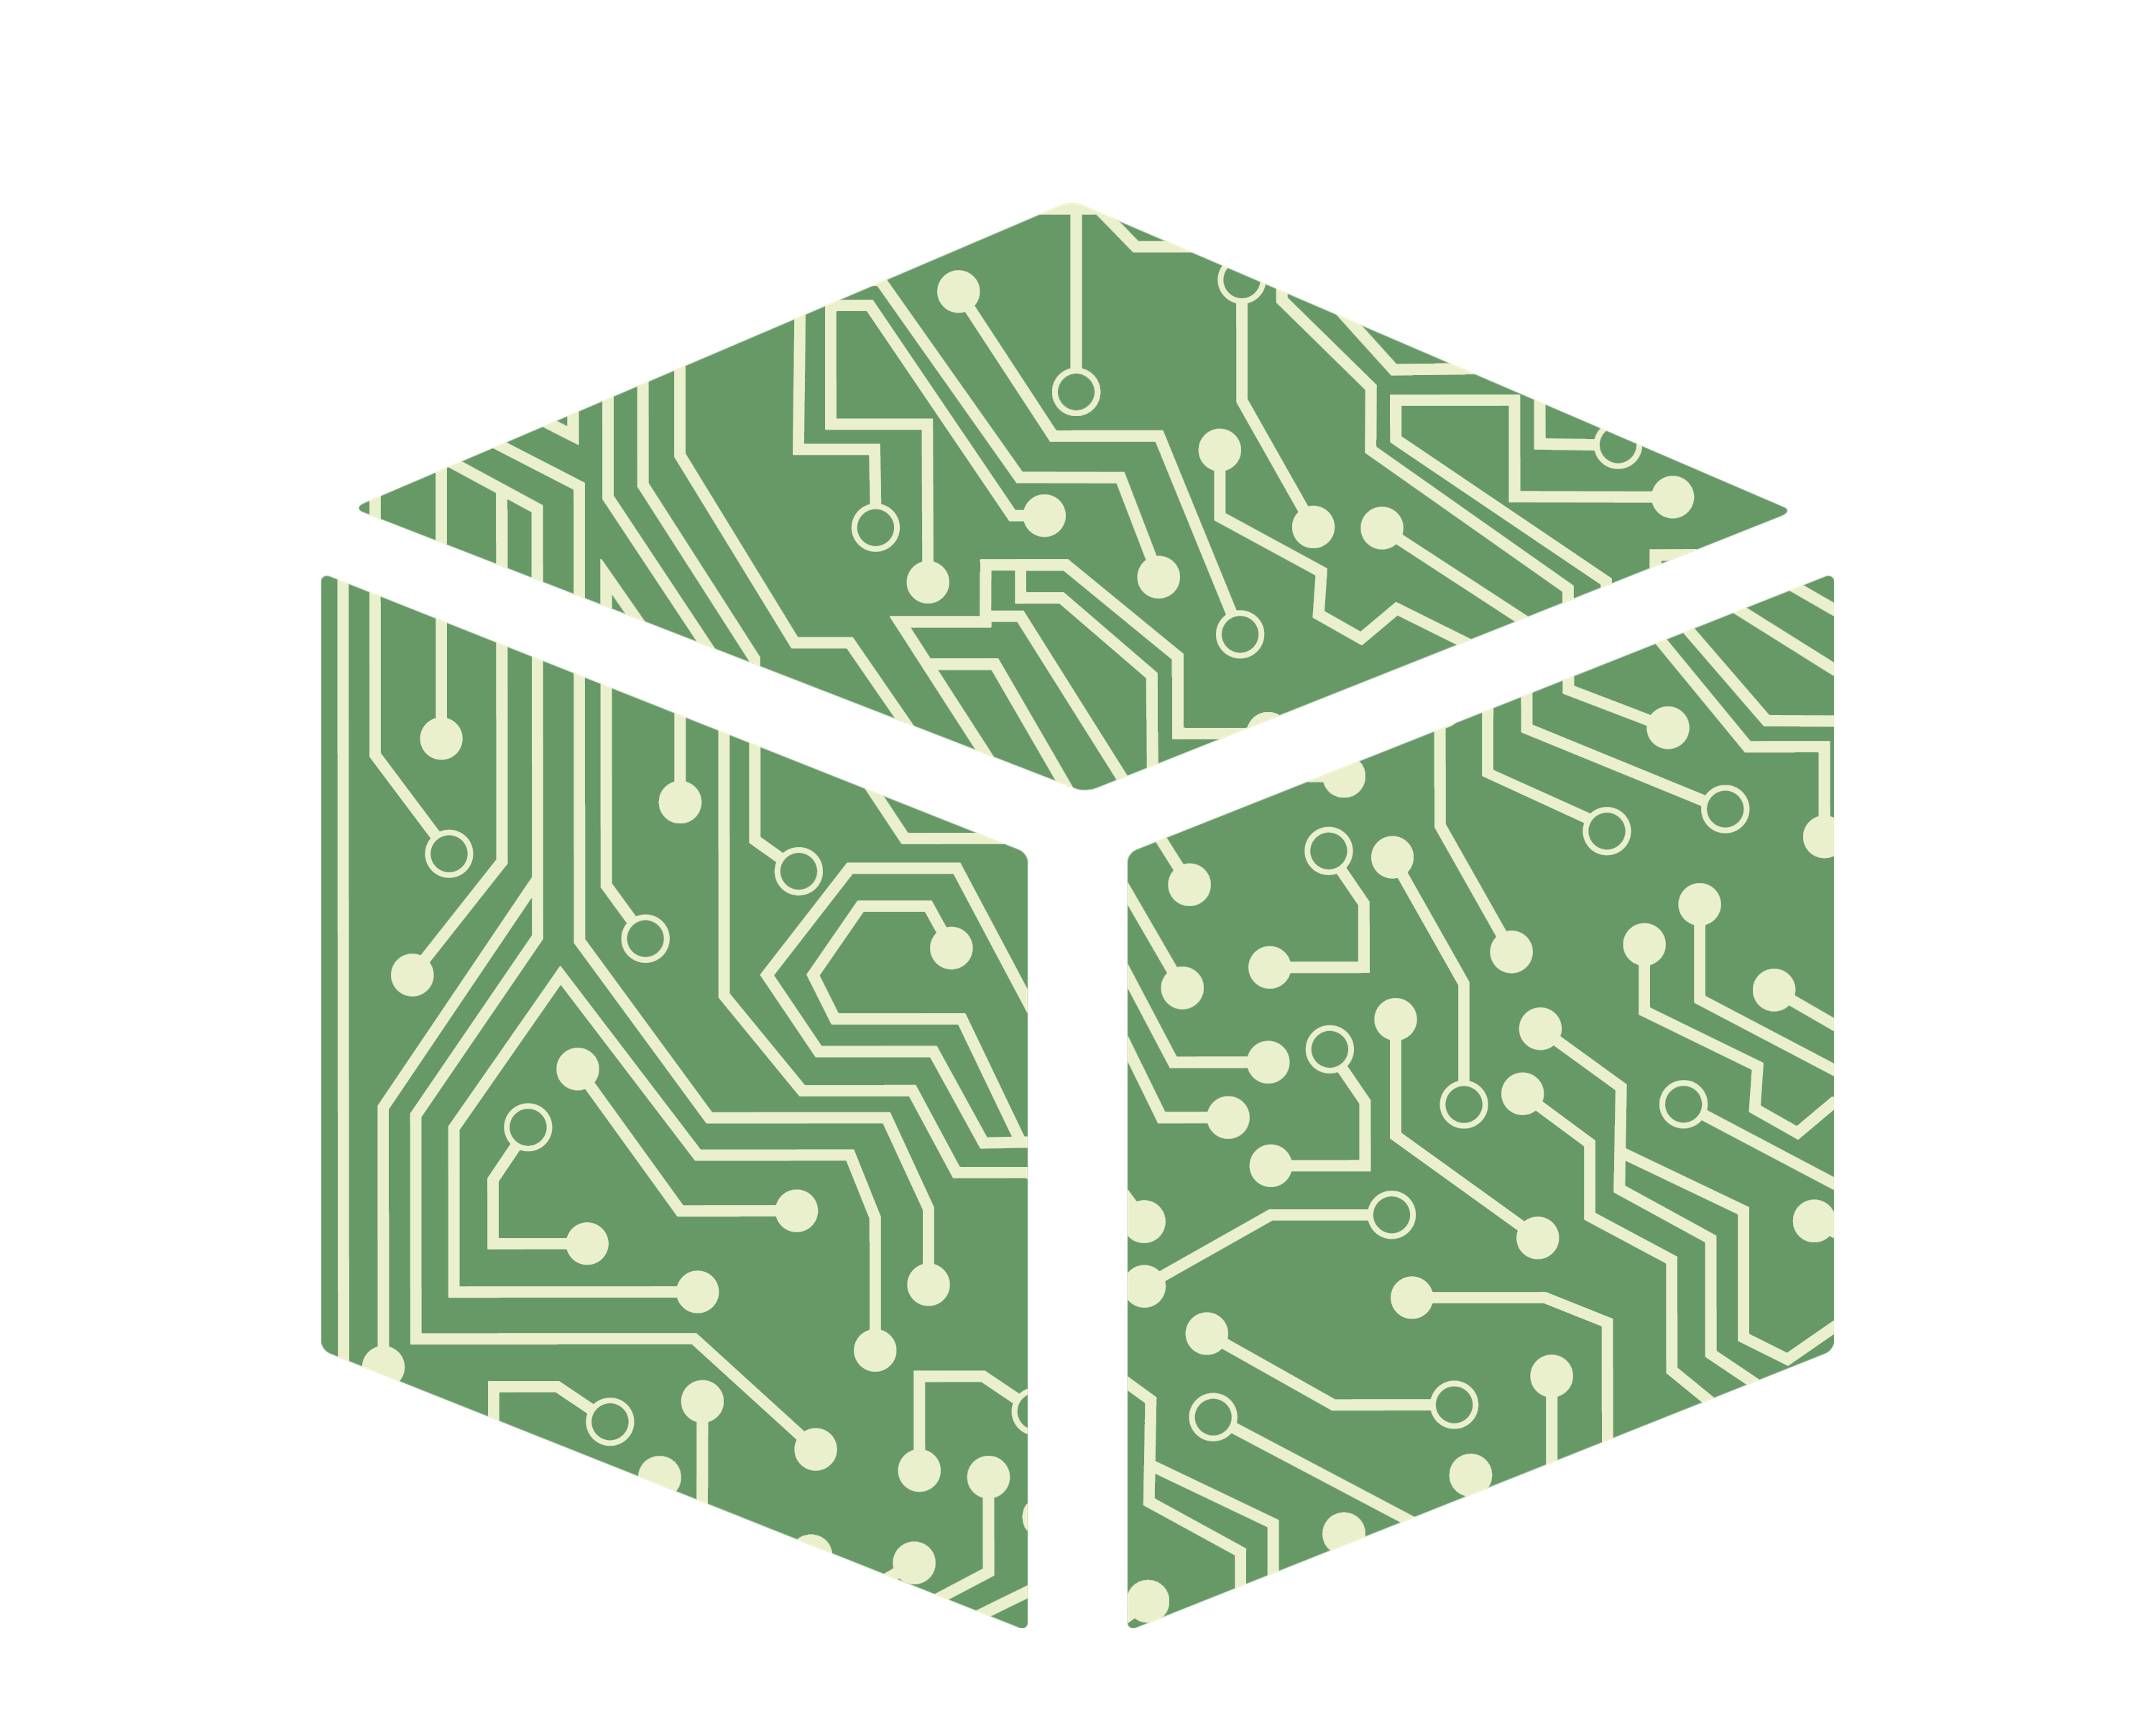
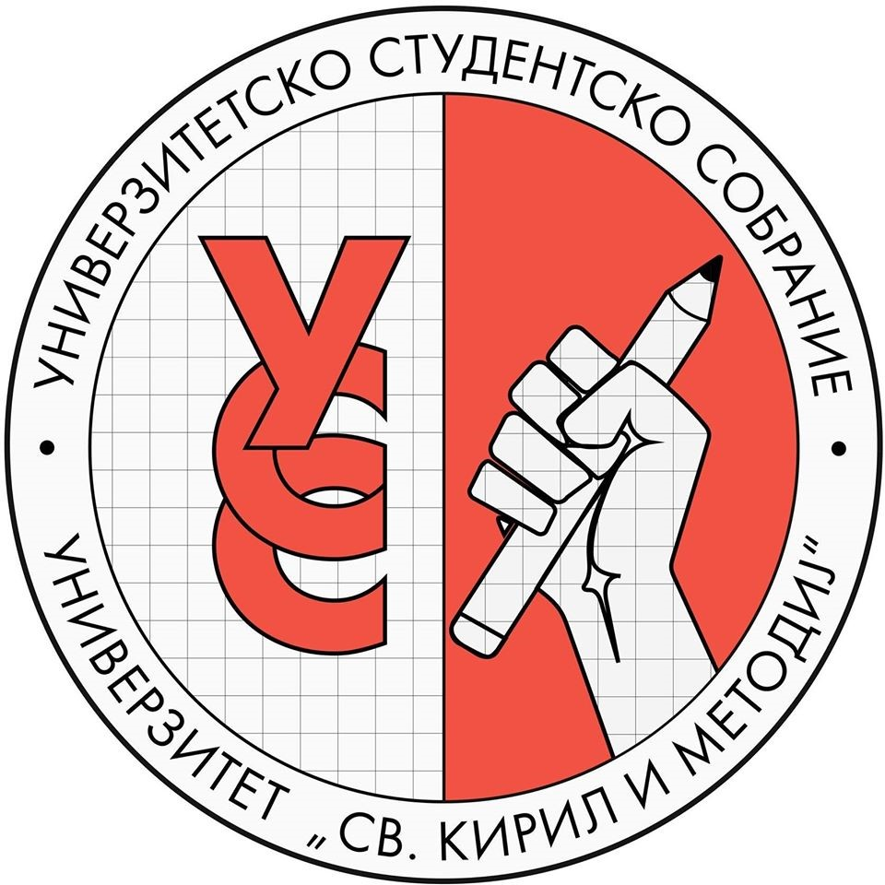
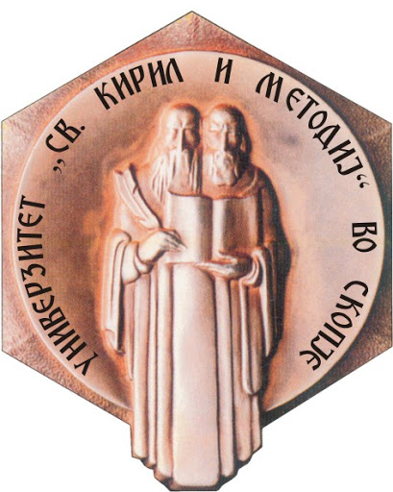
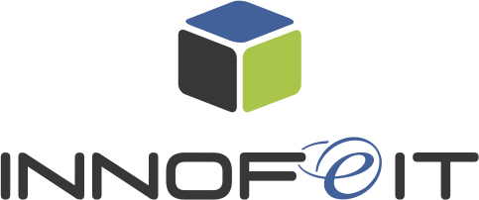

I N N O V A T I O N S I N S M A R T A N Y T H I N G E V E R Y W H E R E

I N N O – S A E 2 0 2 1

P R O G R A M R U L E S

Article 1

The program Innovations in Smart Anything Everywhere 2020 (INNO-SAE 2020) is organized by the Center for Technology Transfer and Innovations – INNOFEIT at the Ss. Cyril and Methodius University in Skopje and the University Students Assembly at the Ss. Cyril and Methodius University in Skopje. Its main target is to stimulate innovations among students and support development of proof-of-concept solutions that may evolve towards commercial products.
INNO-SAE 2021 specifically focuses on the Smart Anything Everywhere (SAE) initiative of the EC. The objective of this initiative is to ensure that any industry in Europe – big or small, wherever situated and in whichever sector – can fully benefit from digital innovations to upgrade its products, improve its processes and adapt its business models to the digital age.
INNO-SAE 2021 is open to all interested students from UKIM without any restrictions.

Article 2

The program INNO-SAE 2020 starts in May 2021.
The program will be published on relevant social media of INNOFEIT and the Faculty of Electrical Engineering and Information Technologies (FEEIT) – Skopje.
All relevant materials for the program will be timely published on the INNOFEIT’s web page (inno.feit.ukim.edu.mk).
The program INNO-SAE 2021 comprises 3 parts:
- Submissions – from start to 1.07.2021
- Evaluation – from 2.07.2021 to 10.07.2021
- Development work - from 11.07.2021 to 31.08.2021

Article 3 - SUBMISSIONS

The program INNO-SAE 2021 solicits submissions from student teams with preferential treatment of interdisciplinary teams formed from students studying on different faculties of UKIM.
The student teams can be up to 5 students.
Each team submits an idea with clear elaboration (objectives and outcomes) and a list of necessary consumables for realization of the idea into a viable proof-of-concept.
The ideas must show innovation component and have sufficient novelty.

Article 4 – NETWORKING AND ORIENTATION DAYS

To ease the communication within the interdisciplinary teams formed from students studying at different faculties, INNOFEIT will organize networking and orientation days on-demand via teleconferencing.
These events will be timely announced through relevant channels. All interested students are invited to participate and gain more information regarding the program INNO-SAE 2021.

Article 5 - EVALUATION

A selected jury of people from academia, industry and business support organizations will conduct the evaluation phase. The names of the jury members will be published in due course.
The evaluation will specifically focus on the viability of the proposed idea and its market potential.
The evaluation will result in a selection of teams that will proceed to the development work phase. INNOFEIT in coordination with UKIM will select a mentor for each of these selected teams (if required). The mentor will be responsible for monitoring the development work and guaranteeing the development of a proof-of-concept solution.
Each of the selected teams will be reimbursed up to 30.000 MKD for the consumables costs (receipts needed) for the development.
Financial reimbursement is foreseen only for the teams that will be selected in the evaluation phase.

Article 6

The developed proof-of-concept solutions by the selected teams will be publicly presented at a special event organized in the latter part of 2021.
All teams that will be transformed into startups will receive support from INNOFEIT to prepare applications for funding from domestic and international sources.

